Final Year Project
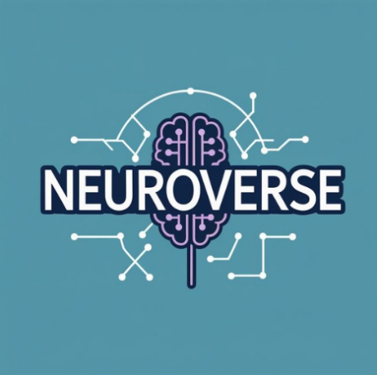
Defense Proposal

FYP Team
Muhammad Naeem
Muhammad Bilal Hassan
Haider Abbas

Supervised by
Dr. Sahar Ajmal

Department of Computer Science
National University of Computer and Emerging Science
Chiniot, Pakistan
2025

Anti-Plagiarism Declaration

This is to declare that the above publication produced under the:
Title: ________________________________
is the sole contribution of the author(s) and no part hereof has been reproduced on as it is basis (cut and paste) which can be considered as Plagiarism. All referenced parts have been used to argue the idea and have been cited properly. I/We will be responsible and liable for any consequence if violation of this declaration is determined.
Date: ______________
Student 1
Name: _____________________

Signature:___________________
Student 2
Name: _____________________

Signature:___________________
Student 3
Name: _____________________

Signature:___________________

Abstract
Alzheimer’s disease (AD) and Parkinson’s disease (PD) together affect more than 65 million people worldwide, and dementia cases alone are projected to triple by 2050, creating one of the greatest public health challenges of this century. In Pakistan, the problem is amplified by an extreme shortage of neurologists — approximately one per 1–1.5 million people — and the limited availability of advanced diagnostic facilities such as MRI and PET scans, which are both costly and concentrated in urban centers. As a result, most patients are diagnosed late, when disease progression is advanced and treatment options are limited.
NeuroVerse addresses this gap by introducing a smartphone-based, multimodal, explainable AI platform for early screening and continuous monitoring of AD and PD. Using only built-in sensors, the system digitizes validated neurological tasks — including speech and language assessments, memory and cognitive stress tests, motor evaluations (tapping and spiral drawing), facial and blink analysis, and gait/turn monitoring. These are translated into calibrated risk indices (0–100) that enable both stage classification (e.g., CN, MCI, AD stages; PD subtypes) and longitudinal progression tracking.
A novel contribution of NeuroVerse is the integration of saliency maps on digital biomarkers, which visually highlight the specific pauses, tremors, irregular movements, or expressions that influenced the AI’s prediction. This explainability feature improves trust, interpretability, and clinical adoption. Furthermore, a digital wellness correlator connects lifestyle factors such as screen time, gaming habits, and sleep patterns with cognitive decline, offering a more holistic view of neuro health. To ensure global scientific contribution, the project also introduces the Urdu-English multimodal dataset for AD and PD, providing a valuable resource for research communities in both local and international contexts.

Table of Contents
Table of Figures 1
List Of Tables 2
1. Vision Document 3
1.1. Introduction 3
1.1.1. Problem Statement: 3
1.1.2. Objectives 3
1.2. Motivation 4
1.3. Overview 4
1.4. Functionality 4
1.4.1. User Profiles 5
1.4.2. Multimodal Test Modules 5
1.4.3. Explainability with Saliency Maps 5
1.4.4. Digital Wellness Correlator 5
1.4.5. Risk Dashboard & Reports 6
1.4.6. AI Health Coach 6
1.4.7. Open Research Data Hub 6
2. Tools and Technologies 6
2.1. Visual Studio Code (VS Code) 6
2.2. Flutter 6
2.3. PyTorch & TensorFlow Lite 7
2.4. OpenCV & MediaPipe 7
2.5. SHAP, Captum & Grad-CAM 7
2.6. Firebase 7
2.7. Supabase (Optional) 7
3. Required hardware and Software resources 8
3.1. Hardware 8
3.2. Software 8
4. High Level Diagram 9
5. Timeline 9
6. Related Projects / Novelty 10
7. References 11

Table of Figures
Figure 2.1.1. VS Logo 6
Figure 2.2.1. Flutter Logo 6
Figure 2.3.1. TensorFlow Logo 7
Figure 2.4.1. OpenCV Logo 7
Figure 2.5.1 SHAP Logo 7
Figure 2.6.1. Firebase Logo 7
Figure 2.7.1. Supabase Logo 7
Figure 4.1. Architectural Diagram 9
Figure 5.1. Project Timeline 9
Figure 6.1. Comparison Table 10

List Of Tables
Table 3.1.1. Hardware Requirements 8
Table 3.2.1. Software Requirements 8

Vision Document

Introduction

Problem Statement:
Alzheimer’s and Parkinson’s are progressive, irreversible neurodegenerative diseases that are usually diagnosed late, when treatment is least effective. Globally, dementia affects 55 million people, projected to triple by 2050, while Parkinson’s impacts over 10 million individuals.
In Pakistan, the situation is worsened by a critical shortage of neurologists and limited access to advanced diagnostics, which are both costly and restricted to major urban hospitals. Existing AI-based solutions have shown promise, but they are mostly single-modality (MRI-only, speech-only, or gait-only), trained on Western/English datasets, and act as black boxes that lack transparency. These limitations reduce their reliability, trust, and local applicability.
There is therefore a pressing need for an accessible, explainable, and localized system that can screen for AD and PD using widely available smartphones.

Objectives
- Develop a smartphone-based multimodal platform for early screening and continuous monitoring of Alzheimer’s and Parkinson’s disease.
- Digitize validated neurological tasks (speech, memory, motor, facial/blink, gait) using only built-in phone sensors.
- Perform stage classification (CN, MCI, AD; PD subtypes) and continuous progression tracking with calibrated risk indices (0–100).
- Integrate explainability via saliency maps on digital biomarkers to make AI outputs transparent and trustworthy.
- Implement a digital wellness correlator linking screen time, gaming, and sleep with cognitive and motor performance.
- Create the first Urdu-English neuro dataset for AD and PD and establish an open research hub for global use.
- Provide a risk dashboard and personalized AI health coach for reports, progression tracking, and lifestyle guidance.
- Evaluate the system using medical AI standards: sensitivity, specificity, F1-score, ROC-AUC, ICC, and calibration.

Motivation
Neurodegenerative diseases create not only a medical challenge but also a social and economic burden for patients, families, and healthcare systems. In low-resource countries like Pakistan, late diagnosis leads to missed opportunities for early intervention, leaving patients and caregivers with few options.
While AI has potential to address this gap, current solutions are not culturally adapted, not multimodal, and not transparent. What Pakistan and much of the Global South needs is a solution that is low-cost, explainable, and accessible via everyday devices.
NeuroVerse is motivated by this urgent gap. It leverages smartphones for data collection, integrates multimodal digital biomarkers to increase accuracy, and applies saliency maps to build trust. By adding a digital wellness perspective (screen time, gaming, sleep) and contributing a first-of-its-kind Urdu-English dataset, it aims to deliver both local impact and global research value.

Overview
NeuroVerse consists of five main layers:
- Acquisition Layer – Captures speech, cognitive, motor, gait, facial/blink, and wellness data using built-in smartphone sensors.
- Processing & AI Layer – Preprocesses signals, runs per-module AI models, and applies a fusion engine to produce calibrated risk indices and stage classifications.
- Explainability Layer – Generates saliency maps for each module and SHAP explanations for the fusion model, ensuring transparent outputs.
- Backend & Storage Layer – Handles authentication, secure storage of results, and anonymized dataset creation.
- Output Layer – Provides a risk dashboard, PDF reports, AI health coach recommendations, and contributes anonymized data to an open research hub.

Functionality
NeuroVerse will be a smartphone-based application integrated with a secure backend and dashboard. The system will allow users to perform digitized neurological tests using their phone’s microphone, camera, touchscreen, and motion sensors. Based on the inputs, the AI engine will compute calibrated risk indices (0–100) for Alzheimer’s and Parkinson’s disease, provide stage classification and progression tracking, and deliver personalized wellness recommendations.
In addition to detection, the application will emphasize explainability and trust by incorporating saliency maps on digital biomarkers, showing users and clinicians exactly which features (pauses in speech, tremor in spiral, irregular tapping, weak facial expressions, etc.) influenced the AI’s decision. A digital wellness module will correlate screen usage, gaming, and sleep patterns with brain health, while the backend will also serve as an open research hub by anonymizing Urdu-English multimodal data.
The project would have the following major functionalities:

User Profiles
Each user will have a profile containing demographic details (age, gender, language), cognitive and motor test history, wellness usage patterns, and generated reports. Clinicians or research users will have enhanced profiles with access to aggregated results and anonymized datasets.

Multimodal Test Modules
Users will complete smartphone-based neurological tasks:
- Speech & Language: story recall, sustained vowel, picture description.
- Cognitive Stress & Memory: Stroop, N-back, word list recall.
- Motor Tasks: finger tapping, spiral drawing, gait/turn-in-place.
- Facial & Eye Analysis: blink rate, smile velocity, hypomimia detection.

Explainability with Saliency Maps
The system will generate visual explanations for each test:
- Spectrogram heatmaps for speech.
- Highlighted strokes for spiral/tapping.
- Marked regions on face video for hypomimia or blink.
- SHAP bar charts for fusion risk scores.
This ensures transparency and increases trust among users and clinicians.

Digital Wellness Correlator
The app will record and analyze daily digital patterns such as screen time, gaming duration, and sleep disruption. These metrics will be correlated with cognitive/motor test results to provide lifestyle-based brain wellness insights.

Risk Dashboard & Reports
A central dashboard will present:
- Risk indices (0–100) for AD and PD.
- Stage classification (CN, MCI, AD; PD subtypes).
- Longitudinal progression charts.
- Exportable PDF reports for clinicians and caregivers.

AI Health Coach
A personalized module that provides recommendations based on user risk and lifestyle data, including reminders for cognitive exercises, digital detox suggestions, and wellness tips.

Open Research Data Hub
The backend will anonymize multimodal data (Urdu and English) collected through the app, contributing to the first localized dataset for AD and PD in Pakistan. Researchers will be able to access this for model training and global collaboration.

Tools and Technologies


Visual Studio Code (VS Code)

Figure 2.1.1. VS Logo
Visual Studio Code is a lightweight, cross-platform Integrated Development Environment (IDE) widely used for mobile, web, and AI development. Its simplicity, flexibility, and extensive library of extensions make it suitable for integrating Flutter, Python (ML models), and backend APIs in one place.


Flutter
Flutter is Google’s open-source framework for building cross-platform mobile applications with a single codebase. It allows the development of Android and iOS applications for NeuroVerse, ensuring that the app can reach the maximum number of users without requiring separate builds.
Figure 2.2.1. Flutter Logo

Figure 2.2.1


PyTorch & TensorFlow Lite
Figure 2.3.1
Figure 2.3.1. TensorFlow Logo

Figure 2.3.1. TensorFlow Logo
PyTorch will be used for training deep learning models (speech, motor, cognitive, and face/eye tasks), while TensorFlow Lite will allow on-device inference for running models efficiently on smartphones. This ensures that AI modules work offline and in real-time.


OpenCV & MediaPipe
Figure 2.4.1
Figure 2.4.1. OpenCV Logo
OpenCV and MediaPipe will be used for computer vision tasks such as facial landmark detection, blink tracking, and spiral/tapping analysis. They enable accurate processing of visual inputs using the smartphone’s camera and touchscreen.


SHAP, Captum & Grad-CAM

These libraries will generate saliency maps and explanations for the AI models. They make the system transparent and trustworthy by showing which features (speech pauses, tremor strokes, irregular tapping, weak facial expressions) influence predictions.
Figure 2.5.1 SHAP Logo


Firebase

Figure 2.6.1. Firebase Logo
Firebase is a backend-as-a-service (BaaS) platform that provides authentication, real-time database, cloud storage, and notifications. In NeuroVerse, it will manage secure user profiles, store test histories, and enable communication between the app and cloud.


Supabase (Optional)
Figure 2.7.1. Supabase Logo
Figure 2.7.1
An open-source backend with PostgreSQL database support, useful for storing anonymized multimodal data for the Urdu-English dataset and open research hub.

Required hardware and Software resources

Hardware

Following development PC is required to develop this project
Table 3.1.1. Hardware Requirements
Hardware | Specifications
Development PC | - Microsoft Windows 10/11(64 bit) or  Ubuntu 20.04+.  Intel i5/i7 or AMD equivalent Processor.  8 GB RAM recommended (16 GB for training AI models).  256 GB SSD/500 GB HDD.  Dedicated GPU with ≥4 GB VRAM.  Screen resolution 1280 * 800 or higher.
Test Smartphone | - Android device with ≥3 GB RAM, accelerometer, gyroscope, microphone, and front camera.  - Screen resolution 1280 * 800 or higher.  - Android version 9.0 (Pie) or above.

Software

Following software’s are required for the development of this project
Table 3.2.1. Software Requirements
Software | Purpose
Visual Studio Code | Default IDE
Flutter SDK | Mobile Development
Firebase / Supabase | Backend Services
PyTorch & TensorFlow Lite | AI/ML Frameworks
OpenCV & MediaPipe | Computer Vision
Librosa / Torchaudio | Audio Processing
SHAP, Captum, Grad-CAM | Explainability (XAI)
MS Visio / Draw.io | UML Designing
Figma / Adobe XD | UI/UX Designing

High Level Diagram

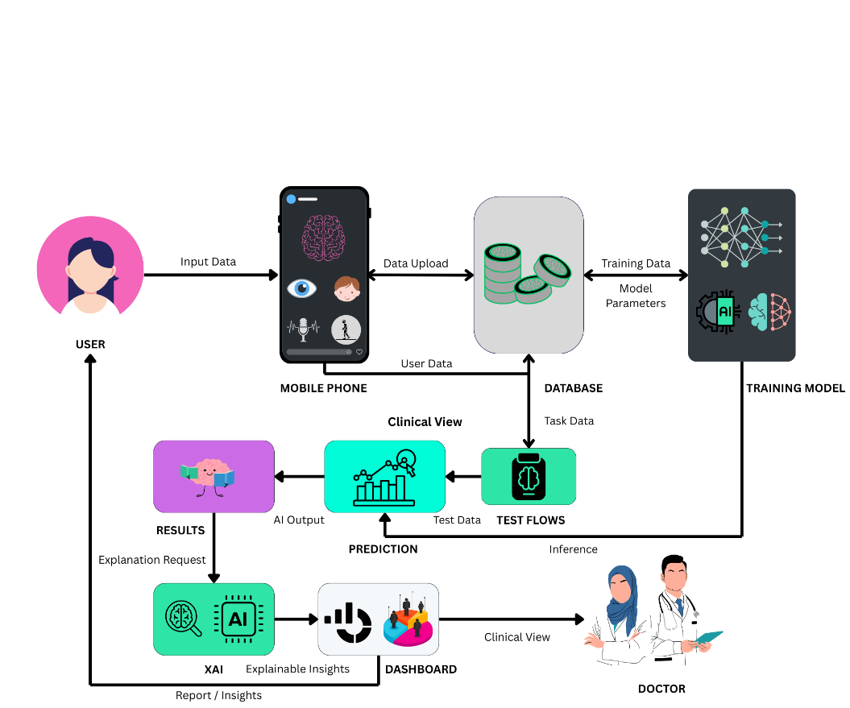
Figure 4.1. Architectural Diagram

Timeline

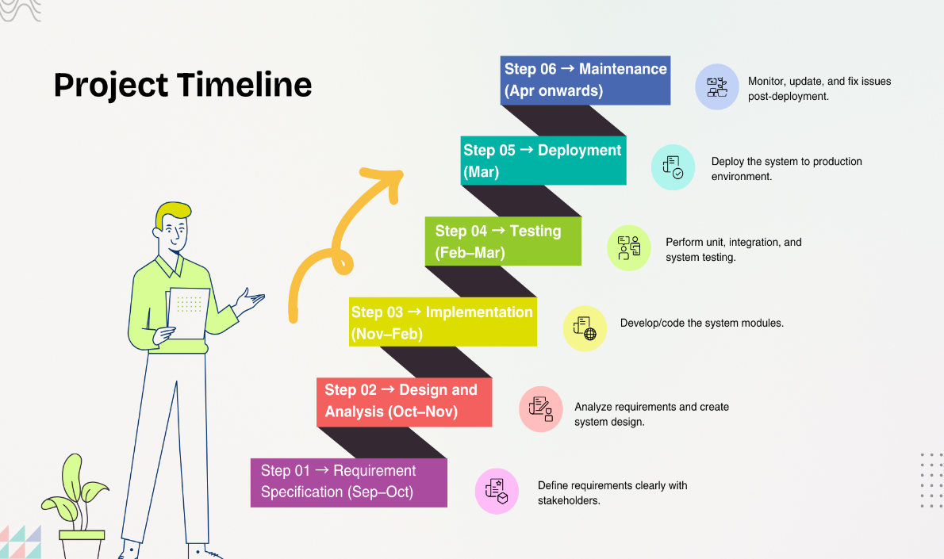
Figure 5.1. Project Timeline

Related Projects / Novelty
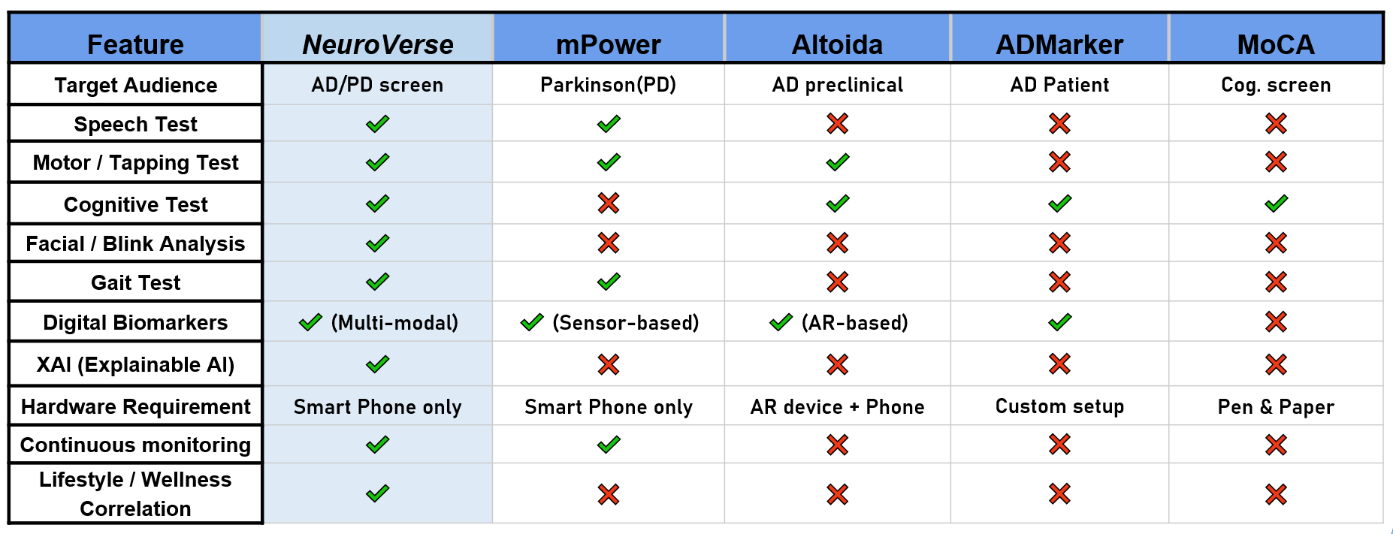
Figure 6.1. Comparison Table

References

[1] | B. M. S. C. N. E. A. K. E. K. M. B. E. G. L. H. Bot, "The mPower study, Parkinson disease mobile data collected using ResearchKit," Scientific Data, vol. 3, pp. 1-9, Mar 2016.
[2] | M. B. R. R. S. S. M. Muurling, "Augmented reality versus standard tests to assess cognition and function in early Alzheimer’s disease," npj Digital Medicine, vol. 6, no. 1, p. 78, Jun 2023.
[3] | X. Z. L. W. Y. L. H. Ouyang, "ADMarker: A Multi-Modal Federated Learning System for Monitoring Digital Biomarkers of Alzheimer’s Disease," arXiv preprint, Oct 2023.
[4] | N. A. P. Z. S. B. V. C. S. W. V. C. I. C. J. L. C. H. Nasreddine, "The Montreal Cognitive Assessment, MoCA: a brief screening tool for mild cognitive impairment," Journal of the American Geriatrics Society, vol. 53, no. 4, p. 695–699, Apr 2005.
[5] | W. Z. X. W. B. S. Y. D. C. S. S. L. J. Z. K. H. Y. Z. M. Y. S. D. Y. S. H. K. J. L. X. J. G. B. L. F. H. P. L. C. H. Y. Z. X. G. C. S. Qi, "Alzheimer’s disease digital biomarkers multidimensional landscape and AI model scoping review," npj Digital Medicine, vol. 8, p. Article number 366, 2025.
[6] | A. e. a. Chudzik, "Machine Learning and Digital Biomarkers Can Detect Early Neurodegenerative Disease — A Review," Sensors (MDPI), vol. 24, no. 5, 2024.

